Dinkarrao K. Shinde Smarak Trust’s,  DR. A. D. SHINDE  INSTITUTE OF TECHNOLOGY  Approved by AICTE, Delhi, DTE Mumbai and Govt. of Maharashtra, Affiliated to MSBTE, Mumbai. | 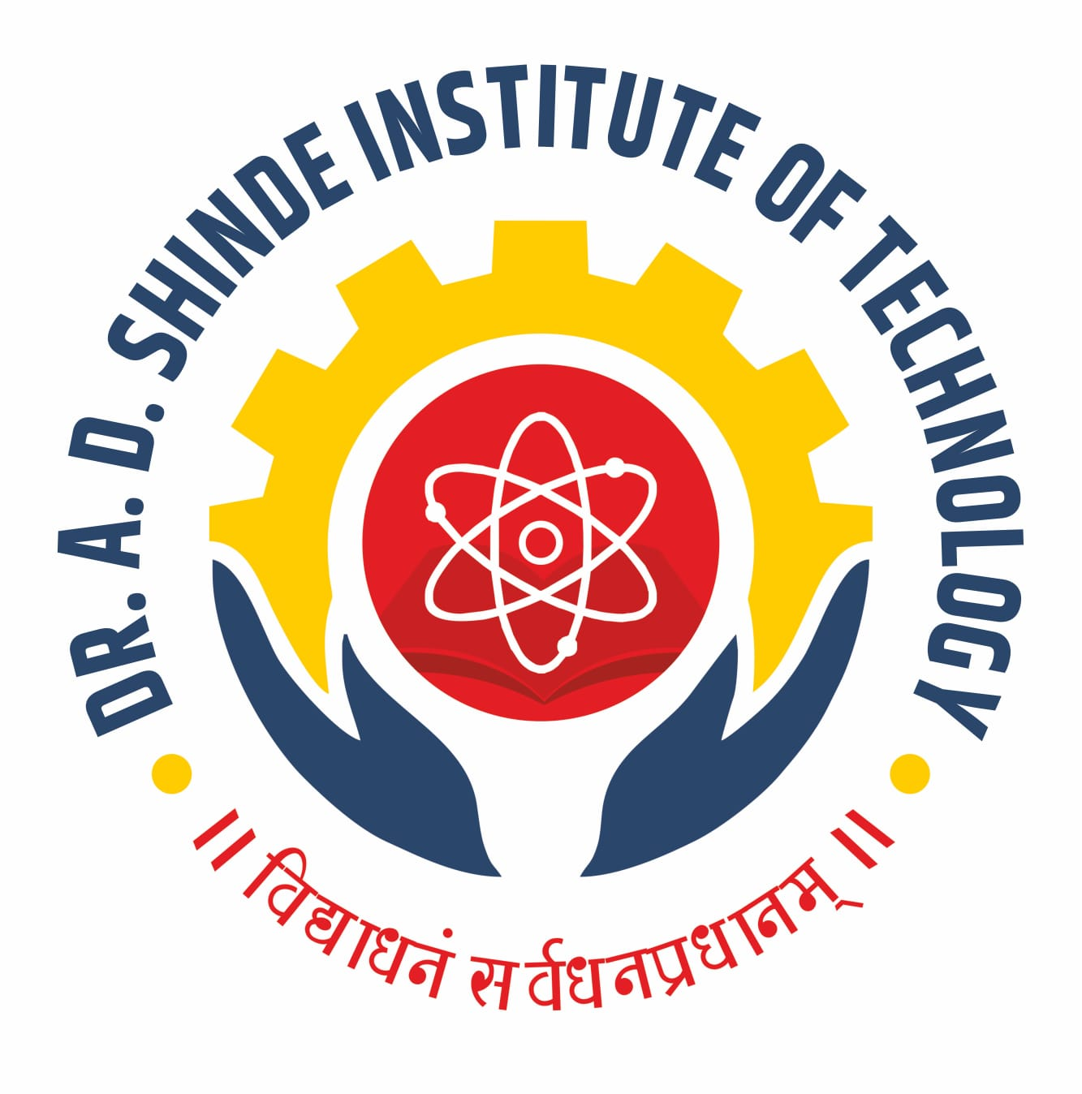
=========================================================================

DEPARTMENTAL TIME TABLE

Academic Year | 2025-26 | Program Name | AN
Semester | 1K | Class & Division | FY B

TIME/DAY | MON |  | TUE | WED | THU | FRI | SAT
09.45 -10.45 | CHEM |  | EGP | ICT-B1  EGP-B2 | BMS | EGP | PHY
10.45-11.45 | ICT |  | BMS | ICT-B1  EGP-B2 | PHY | BMS | ENG
11.45-12.15 | LONG RECESS
12.15-01.15 | CHEM-B1  ICT-B2 |  | PHY-B1  WPC-B2 | ENG-B1  CHEM-B2 | EGP-B1  PHY-B2 | WPC-B1  EGP-B2 | WPC-B1  ENG-B2
01.15-02.15
02.15-02.30 | SHORT RECESS
02.30-03.30 | BMS | ENG |  | LIB | EGP-B1  WPC-B2 | ENG | BMS
03.30-04.30 | TEST | BMS |  |  | EGP-B1  WPC-B2 | CHEM | YAM

Course Name |  | Course Code | Course Abbr. | Name of the Faculty
Basic Mathematics |  | 311302 | BMS | Ms. Magadum S. S.
Basic Science | Physics | 311305 | BSC | Mrs. Patil S. B.
Basic Science | Chemistry | 311305 | BSC | Ms. Chavan K. K.
Communication Skill (English) |  | 311303 | ENG-TH | Mr. Kamble J. B.
 |  | 311303 | ENG-PR | Mr. Kamble J. B.
Engineering Graphics |  | 311008 | EGP | Ms. Bhoi N. R.
Engineering Workshop Practices |  | 311002 | WPC | Mr. Kochargi A. N.
Fundamental of ICT |  | 311001 | ICT | Mrs. Kamate S. S.

B1 : AN(01-22) B2 : AN(23-44)

HOD ACADEMIC COORDINATOR PRINCIPAL

