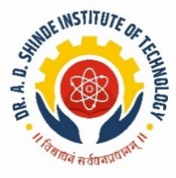 | Dinkarrao K. Shinde Smarak Trust’s,  DR. A. D. SHINDE  INSTITUTE OF TECHNOLOGY  Approved by AICTE, Delhi, DTE Mumbai and Govt. of Maharashtra, Affiliated to MSBTE, Mumbai.
=============================================================================
DEPARTMENT OF ARTIFICIAL INTELLIGENCE AND MACHINE LEARNING

NEWSLETTER

ACADEMIC YEAR- 2025-26 TERM- II
===========================================================================

- FROM THE DESK OF PRINCIPAL

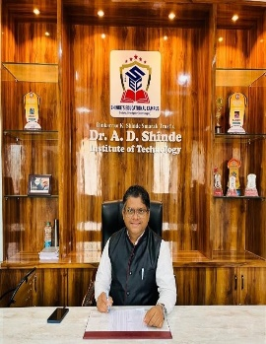 | Dr. A. D. Shinde Institute of Technology stands as a reputed institution dedicated to delivering high-quality technical education. Over the years, the institute has evolved with a strong commitment to fostering creativity, innovation, and professional excellence among its students.  At DADSIOT, excellence is viewed as a continuous journey. The institute consistently strives to nurture and develop world-class technocrats, successful entrepreneurs, capable leaders, and innovative researchers who contribute meaningfully to society.  The institution remains devoted to ensuring the academic, professional, and social growth of aspiring engineers. We extend our best wishes to all students for a rewarding and enriching learning experience at DADSIOT.
Dr. Sanjaykumar M. Ingale
Principal,
Dinkarrao K. Shinde Smarak Trust’s,
Dr. A. D. Shinde Institute Of Technology

- FROM THE DESK OF HOD

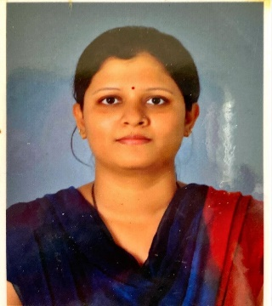 | It is a matter of great pride to present the second edition of the AI & Machine Learning Department Newsletter as we enter our second year. Building on a strong foundation, we continue our journey toward academic excellence and innovation.  Our students have shown remarkable enthusiasm through active participation in learning, projects, and discussions. We remain committed to fostering innovation, research, and industry-oriented learning.  In the coming semesters, we aim to enhance student experience through workshops, technical events, and practical exposure. I sincerely appreciate the efforts of our faculty, students, and contributors, and wish everyone continued success in the evolving AI landscape.  With best wishes..
Mrs. Sonal S. Kamate
Head,
Department of AIML

- ABOUT THE DEPARTMENT

The Artificial Intelligence & Machine Learning (AI & ML) Department at Dr. A. D. Shinde Institute of Technology is a newly established center of excellence dedicated to equipping students with cutting-edge knowledge and hands-on skills in the field of AI. With the world rapidly advancing in automation, data science, and intelligent systems, our department aims to nurture future-ready professionals who can innovate and solve real-world problems using AI technologies.
In our first semester, students have embarked on an exciting academic journey. Our curriculum is designed to provide a strong theoretical foundation combined with practical exposure through coding exercises, projects, and interactive learning sessions.
As we grow, the department will focus on industry collaborations, research-driven initiatives, AI workshops, hackathons, and real-world applications to enhance learning. With a dedicated team of faculty and a passion for innovation, we strive to create a dynamic learning environment that empowers students to excel in AI & ML.
We look forward to shaping the next generation of AI professionals and innovators and contributing to advancements in this transformative field.

- VISION AND MISSIONS

INSTITUTE  VISION | To become an excellent technological institute committed to develop a versatile professional to satisfy the needs of industry, society and the environment
INSTITUTE  MISSIONS | - To provide a quality education to achieve best placement.  - To build leadership qualities to grow professionally and as entrepreneur.  - To develop an industry competent engineer.  - To inculcate a sense of social and environmental responsibilities.
DEPARTMENT  VISION | To become an excellent AIML department committed to provide quality education to satisfy the needs of industry and society.
DEPARTMENT  MISSIONS | 1. To develop logically proficient engineers through state of art education.  2. To develop an industry competent software engineer who can implement knowledge of algorithms and data science for real world projects.  3. To inculcate professional ethics to serve the society.

- LIST OF FACULTIES

Sr | Name of the Faculty | Designation | Specialization
1. | Mrs. Kamate Sonal S. | HOD | M.Tech.(Eln.)
2. | Ms. Patil T. P. | Lecturer | B. Tech. (CSE)
3. | Mr. Kochargi A. N. | Lecturer | B. Tech. (CSE)
4. | Ms. Dhenge D. D. | Lecturer | B.E. (CSE)
5. | Ms. N. B. Patil | Lecturer | Msc (CS)

- DETAILS OF MOUs

Sr | Name of the Organization | Year of MOUs | Year of Validity | Key Features
1. | One IT Solutions,  Gadhinglaj | 2025 | 5 | Provide Training, Software and Web Development
2. | SparkLab IT Solutions, Gadhinglaj | 2025 | 5 | Provide Training, Certifications, Software Developments.
3. | Domain Computer Institute, Gadhinglaj | 2025 | 5 | Services regarding Hardware and Networking
4. | Code Expert Technology, Gadhinglaj | 2025 | 5 | Provide Software Development, E-Commerce Services, SEO services, Android Application Development etc.

- DETAILS OF CO-CURRICULAR ACTIVITIES ORGANIZED

Sr | Name of the Activity | Date | Resource Person | Name of the Topic
1 | Guest lecture | 20/02/2026 | Mr. Shubham Zond | From Spotlight to Success: Mastering Self-Introduction, Confidence & Calm
2 | Guest lecture | 21/03/2026 | Ms. Gayatri Patne | Ace the Interview, Own the Feed: Modern Career Strategies
3 | Industrial Visit | 27/02/2026 | Mr. Kiran Jadhav | Visit to tCognition Kolhapur
4 | Workshop | 12/03/2026  &  13/03/2026 | Mr. Sagar Patil | Practical Database Building for Real-World Projects
5 | Expert Lecture | 17/03/2026 | Mr. Ranjit Vandakar | Opportunities in Cloud Computing

- LIST OF TOPPERS

Class | Name of the Student | Percentage | Rank
FY | SHINDE SAKSHI HEMANT | 88.82% | 1ST
FY | BHOSALE ADITI SANJAY | 84.59% | 2ND
FY | PATIL KUSUM KALGONDA | 83.77% | 3RD

Class | Name of the Student | Percentage | Rank
SY | PATIL SWARA PRAKASH | 81.77% | 1ST
SY | MALAVI PRUTHVIRAJ TANAJI | 80.86% | 2ND
SY | KADAM KASTURI SHASHIKANT | 79.88% | 3RD

- PHOTO GALLERY

Industrial Visit: tCognition Kolhapur

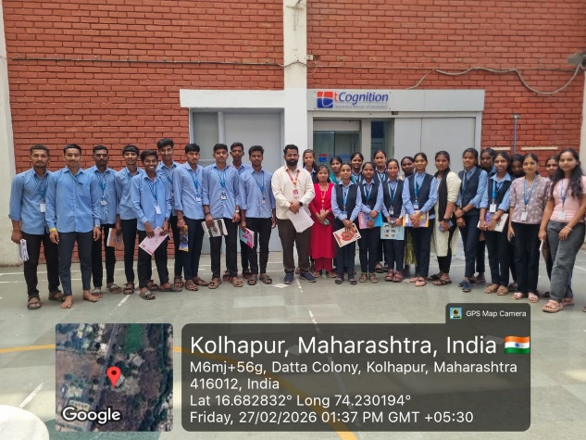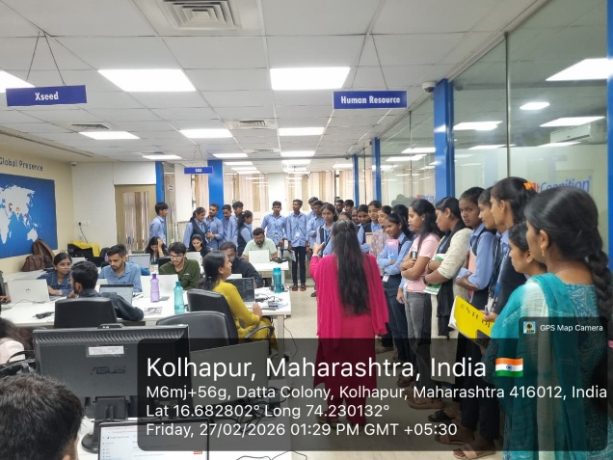

Guest Lecture: From Spotlight to Success: Mastering Self-Introduction, Confidence & Calm

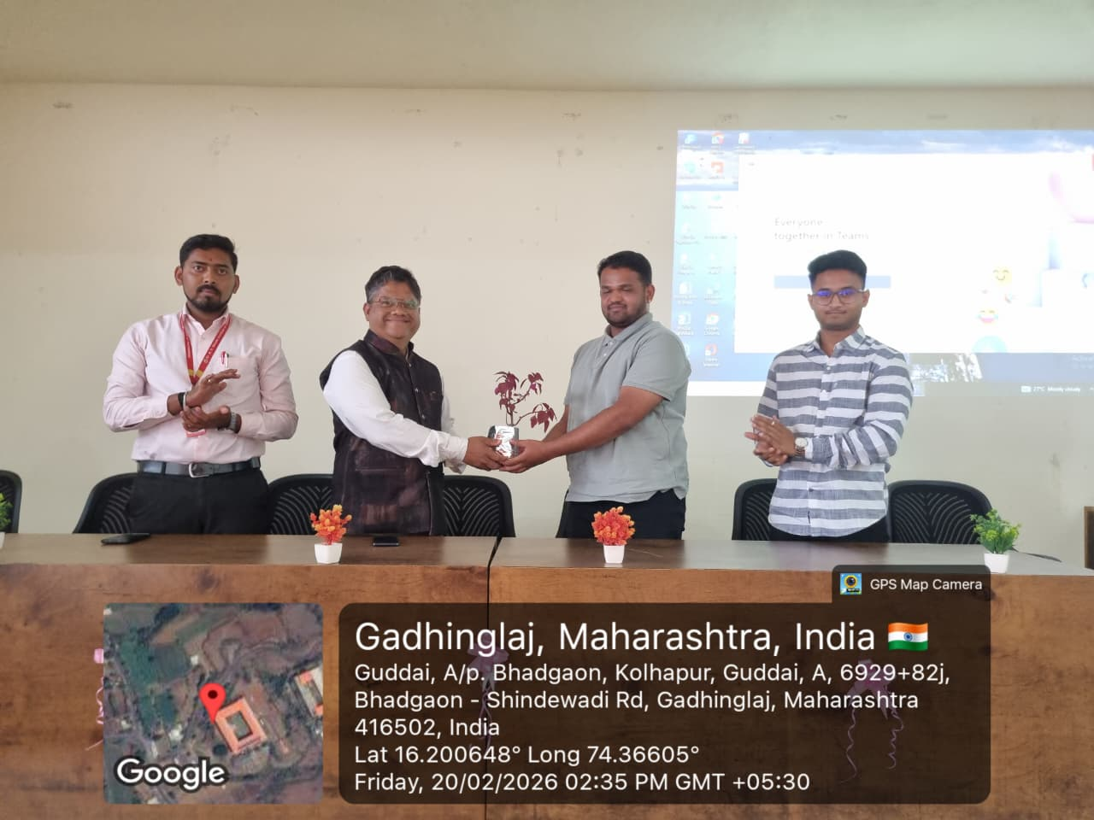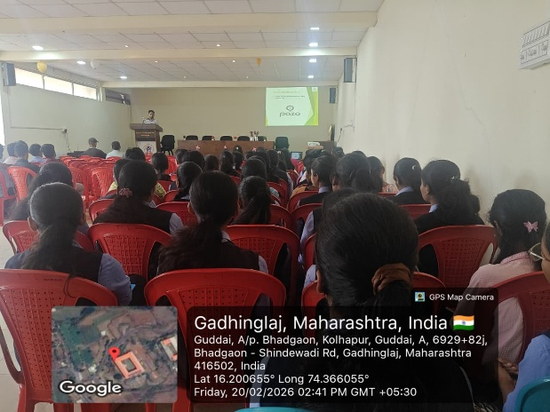

Guest Lecture: Ace the Interview, Own the Feed: Modern Career Strategies

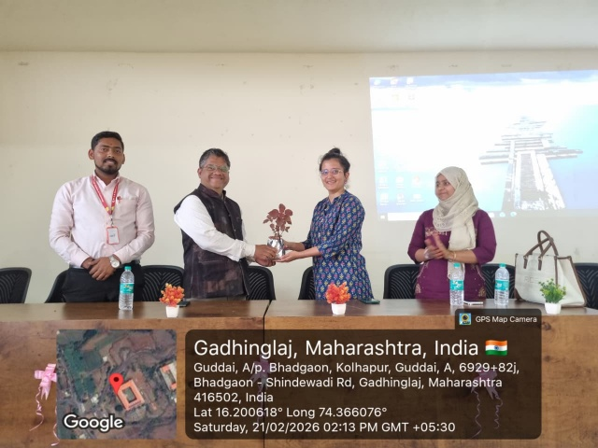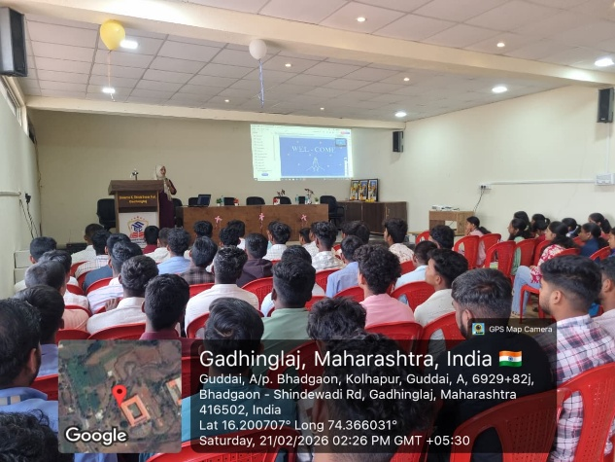

Expert Lecture: Opportunities in Cloud Computing

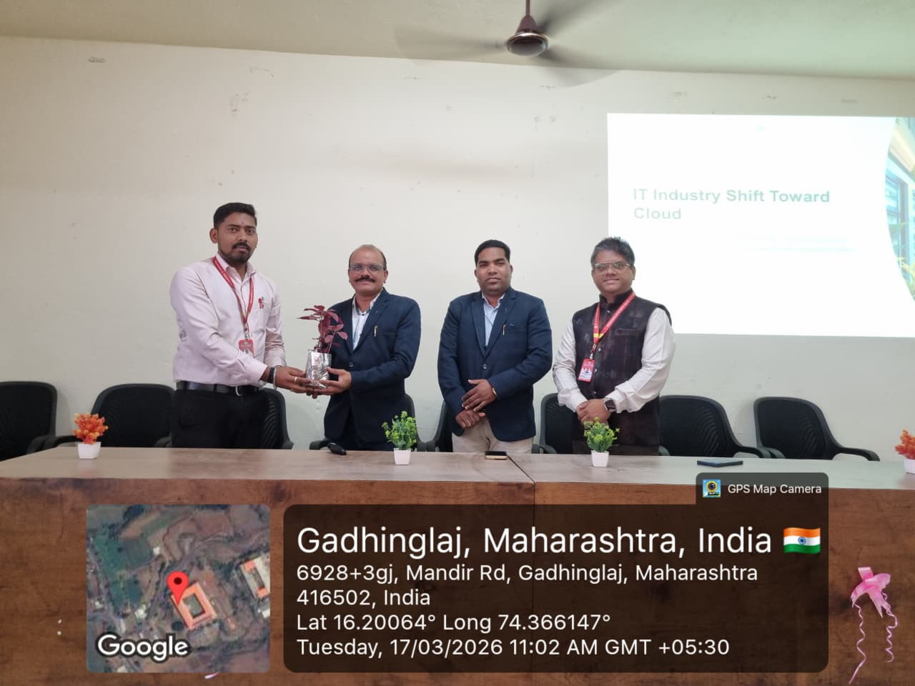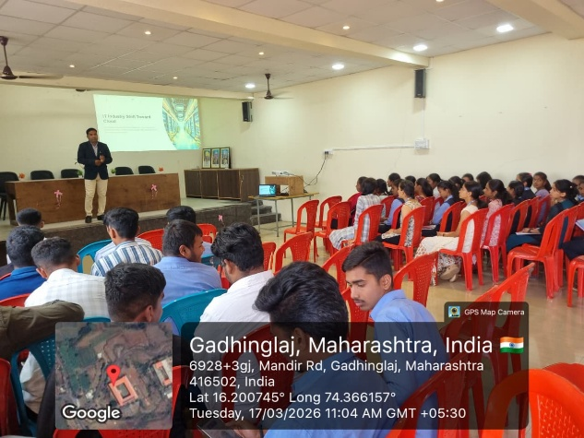

Workshop: Practical Database Building for Real-World Projects

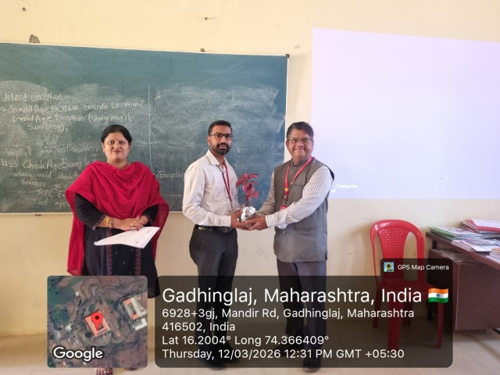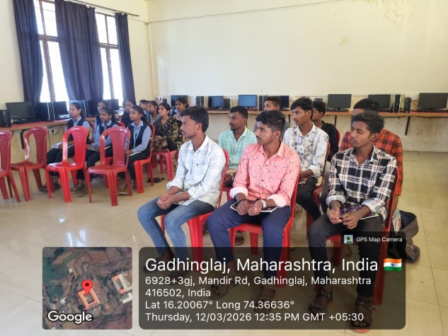

===========================================================================
DEPARTMENT OF ARTIFICIAL INTELLIGENCE AND MACHINE LEARNING
DR. A. D. SHINDE INSTITUTE OF TECHNOLOGY
Guddai, Bhadgaon (Gadhinglaj), Dist- Kolhapur, 416502
www.adshindeiot.edu.in

